The **seqdet5bits_waves.png** simulation results ended before the simulation file terminated execution… Actually and contrary to what the slides said, this solution is for overlapping sequences. If the whole simulation period is shown (**seqdet_ShowsMistake.png**), we see that the output confirms the overlapping mode.

**seqdet5bits_waves.png:**

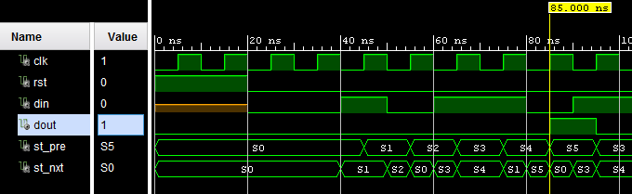

**seqdet_ShowsMistake.png:**

